typedef

1. typedef is a keyword
2. we can use typedef to give new name of a exsisting data_type

syntax - typedef <name of existing data type> <new name of data type>;

typedef int LENGTH;

now we can use LENGTH as a data type which is just same as int :-

int x,y; same as LENGTH x,y;

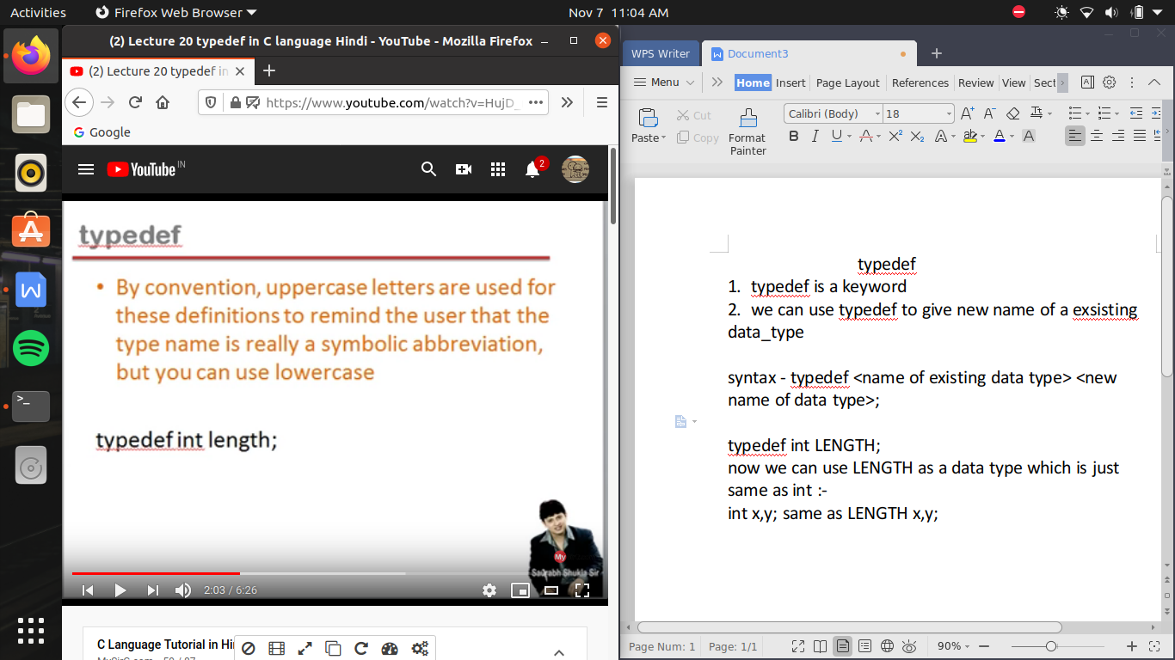

/* use */

#include<stdio.h>

struct strudent

{

int rollno;

char name[20];

int age;

}

void main()

{

struct student s;

}

but if we write typedef before struct then it means

typedef struct student ==>> STUDENT

typedef struct <even we can left it as unnamed> ==>>teacher

now we can use it as

void main()

{

STUDENT s1; //here we don’t even need to write struct every time when ever we write student

teacher s2;

}